Lab 6
There, I switched to Visual Studio Code. That does mean I’ll have to create a GitHub repo every time I finish this thing just to never touch it again, but at least I get complete control over my shell.

Lab6a.py
The entire function could just be a single line using set comprehension.

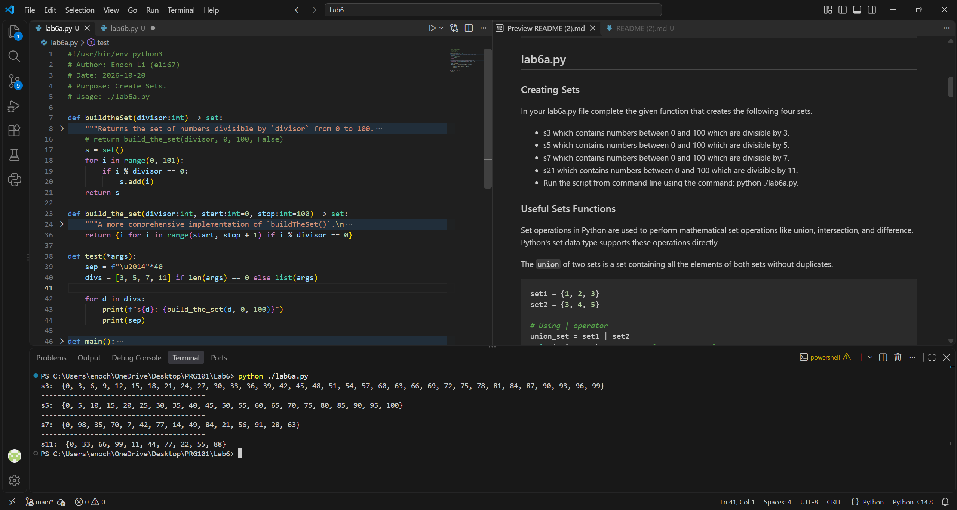
Indeed, that’s how I prefer to declare lists, sets, tuples, dicts, and so on. It isn’t just Pythonic, it is actually easier to read. Also, the test function is your main function but optimised for both testing and readability. You can now input any arbitrary number in there, with no arguments being your original default inputs.

(It has no error-detection, however, because I do not expect it will be used literally anywhere else.)

Lab6b.py
Here’s every number that’s divisible by either 3 or 5, but not both.

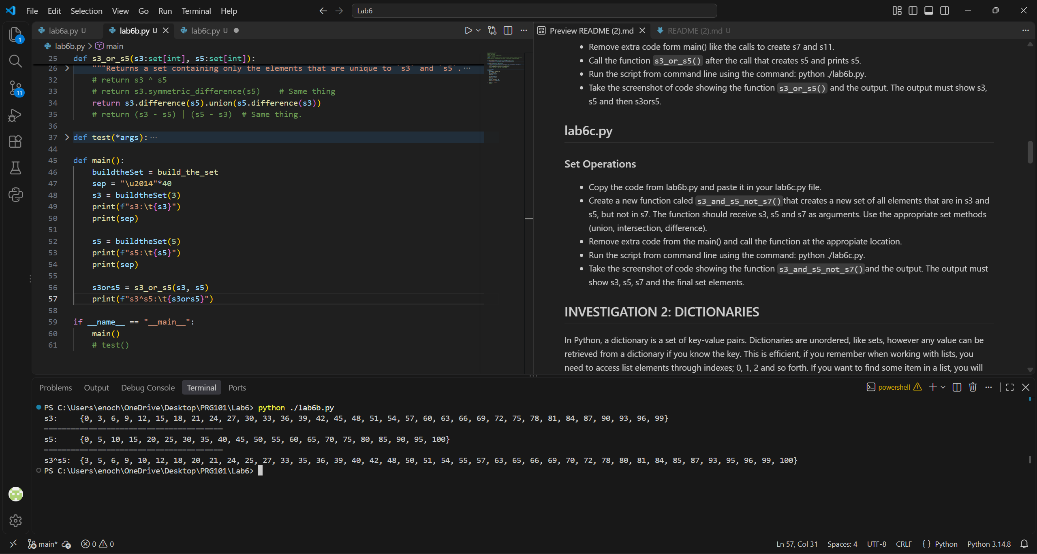
In set theory, this is called an exclusive disjunction, or an XOR, and this particular formulation reads as “A AND NOT B OR B AND NOT A” in Boolean algebra, which is indeed how you define XOR using Boolean connectives as there is not a difference operator in Boolean algebra. However, there is a built-in set function that does this, and that is symbolic_difference. However, it is not in the list of provided “useful sets functions”, so I left it in the comments.

Labc.py
In Boolean algebra, a union is analogous to an OR operator while an intersection is analogous to an AND. As stated previously, a difference does not have a Boolean operator, but it is equivalent to A AND NOT B. Thus, the logic is s3 AND s5 AND NOT s7.

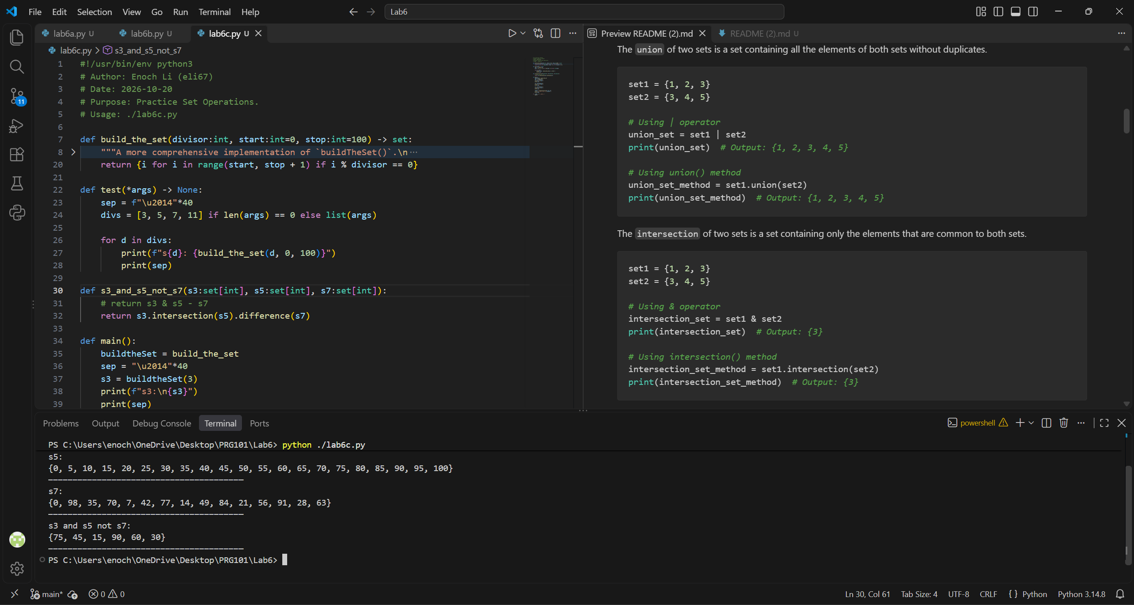
Yep.

Lab6d.py
For a personal project, I’ve created a custom dictionary class called CasefoldedDict that, as the name implied, allowed the user to input case-insensitive strings to perform lookups of values. This was later extended to other datatypes and implemented regex, making it more of a hybrid between a dictionary, a list, and a database. But, it was perfect for what I was using it for, so I deferred any potential future technical debt regarding my implementation choices to my future self.

Unfortunately, I can’t share that with you because the hard drive the project files were located on mysteriously failed when I got back from vacation and I haven’t had the time to get it to a data recovery centre. Most likely, I’ll just rewrite it from memory.

Anyway, you said I’m allowed to use list comprehension. I take that it means I’m allowed to use dictionary comprehension because, like long division, I literally can’t do it the long way any more.

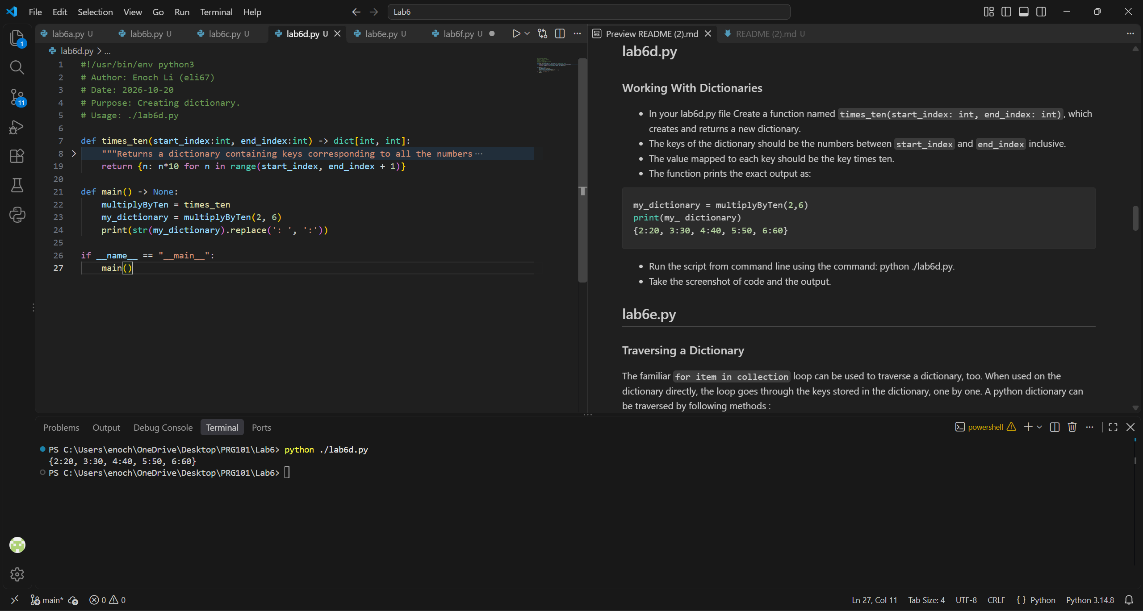
Again, you did say the output had to be exactly the same. Taking the string representation of the dict and deleting all the spaces after the colon is the only fast way I know how to make it do this, with the only alternative being to write a class extending dict (or some other collection) that inherits everything except __str__().

Lab6e.py
Another one-liner?

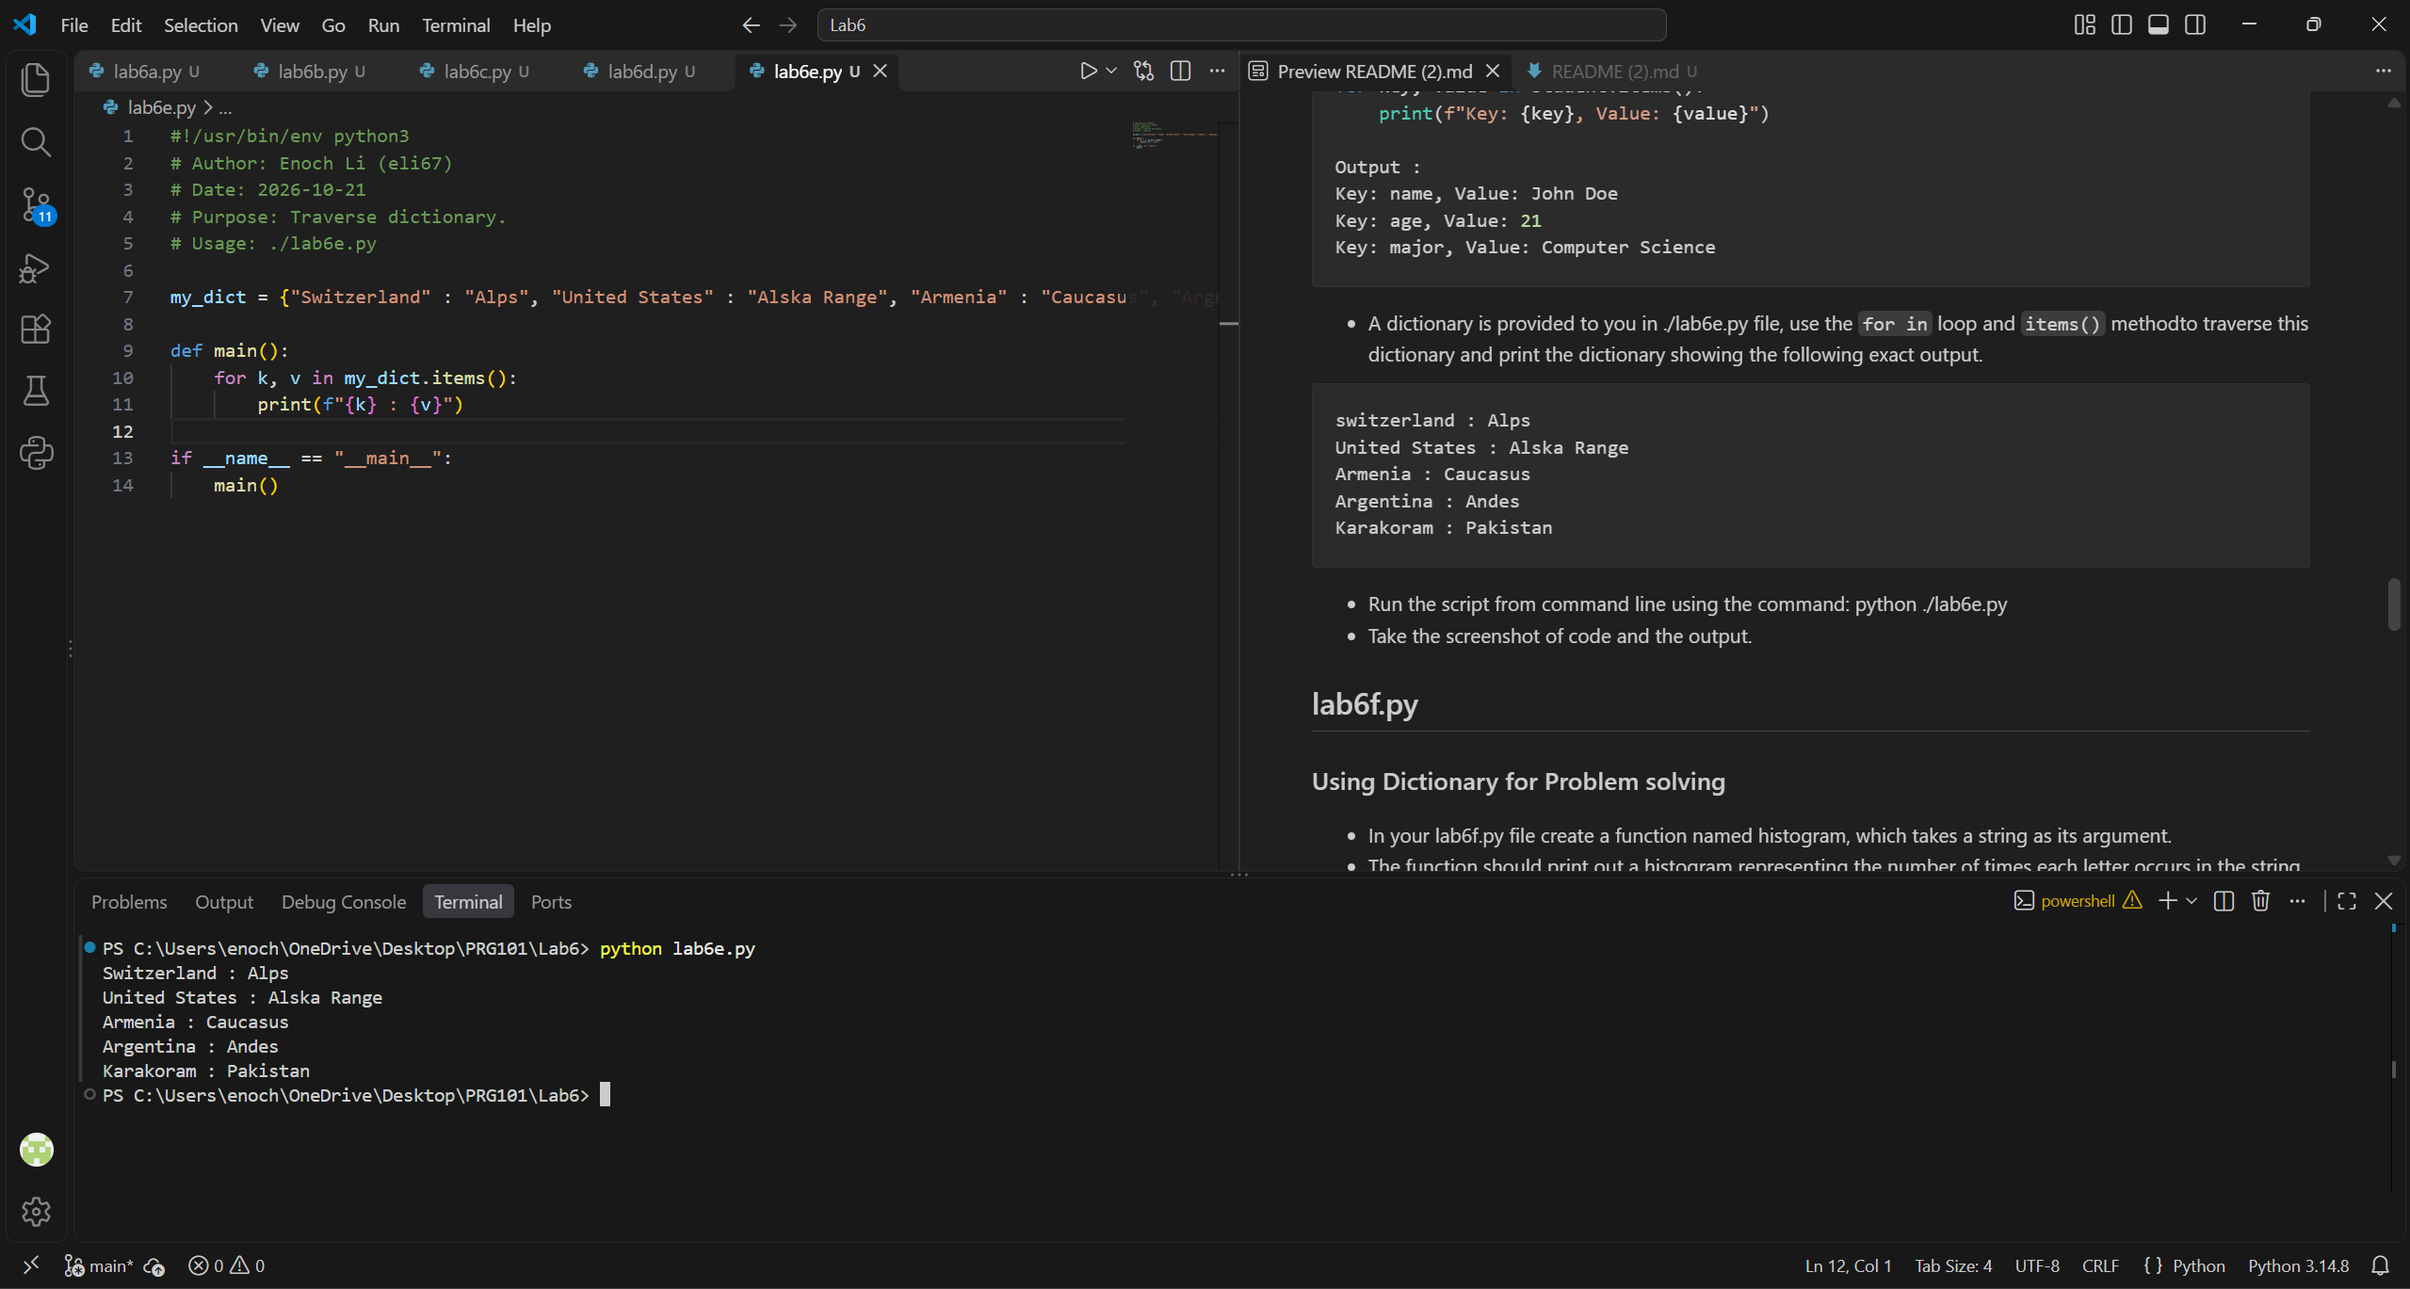
No notes.

Lab6f.py
There is a function in the collections library called Counter that does exactly this, although you do have to cast it back into a dictionary. I have included that as an alternate solution that is theoretically much more flexible and includes features like case sensitivity and the option to remove spaces by default.

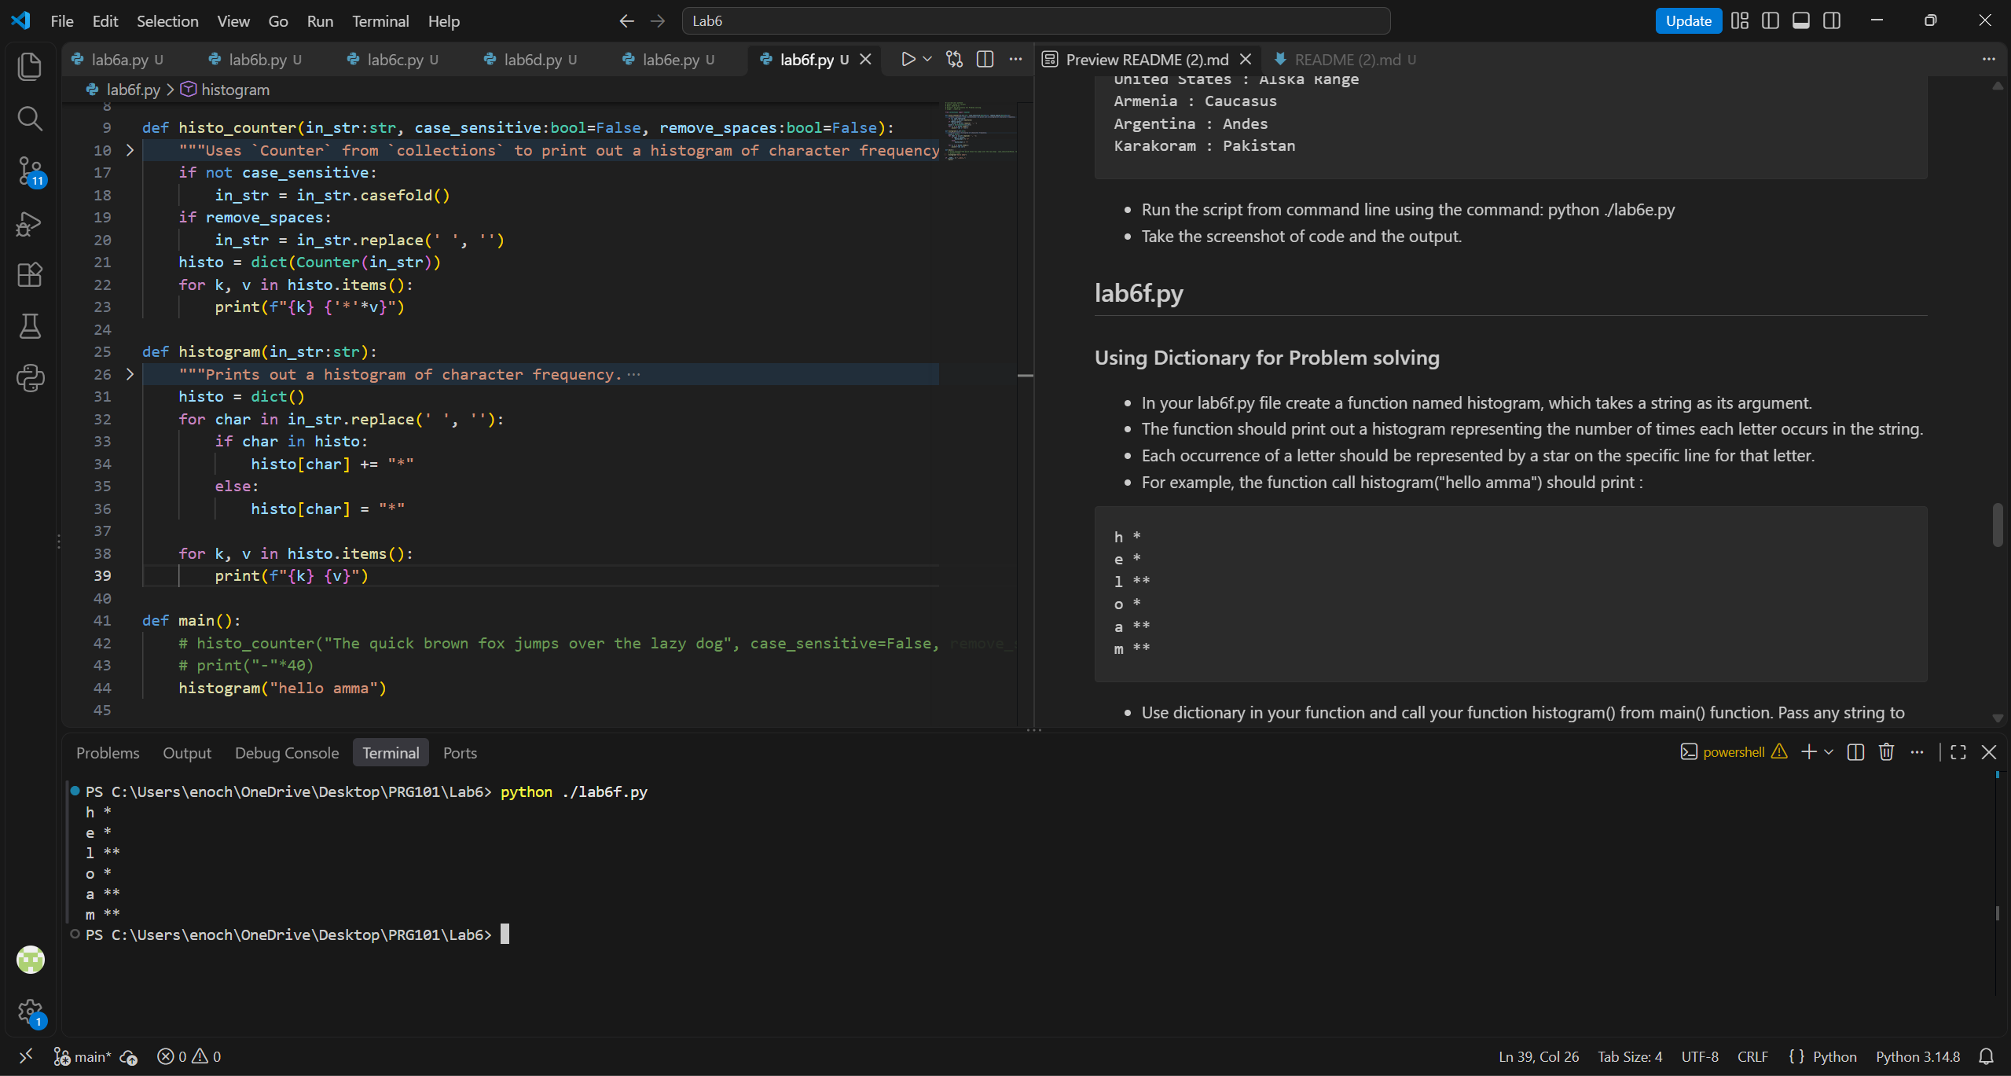
I didn’t want to remove spaces like this, but you did say the output has to look exactly like this.

Lab6g.py
This is where the TypedDict class would really shine as it adds a de-facto static type checker to what is a dictionary in literally every other way. Because of this, the resulting object is still mutable whereas a namedtuple, being a tuple underneath, would be immutable; and because its primary purpose is to store data, it doesn’t need the overhead and methods of actual Python objects that would be required of a dataclass.

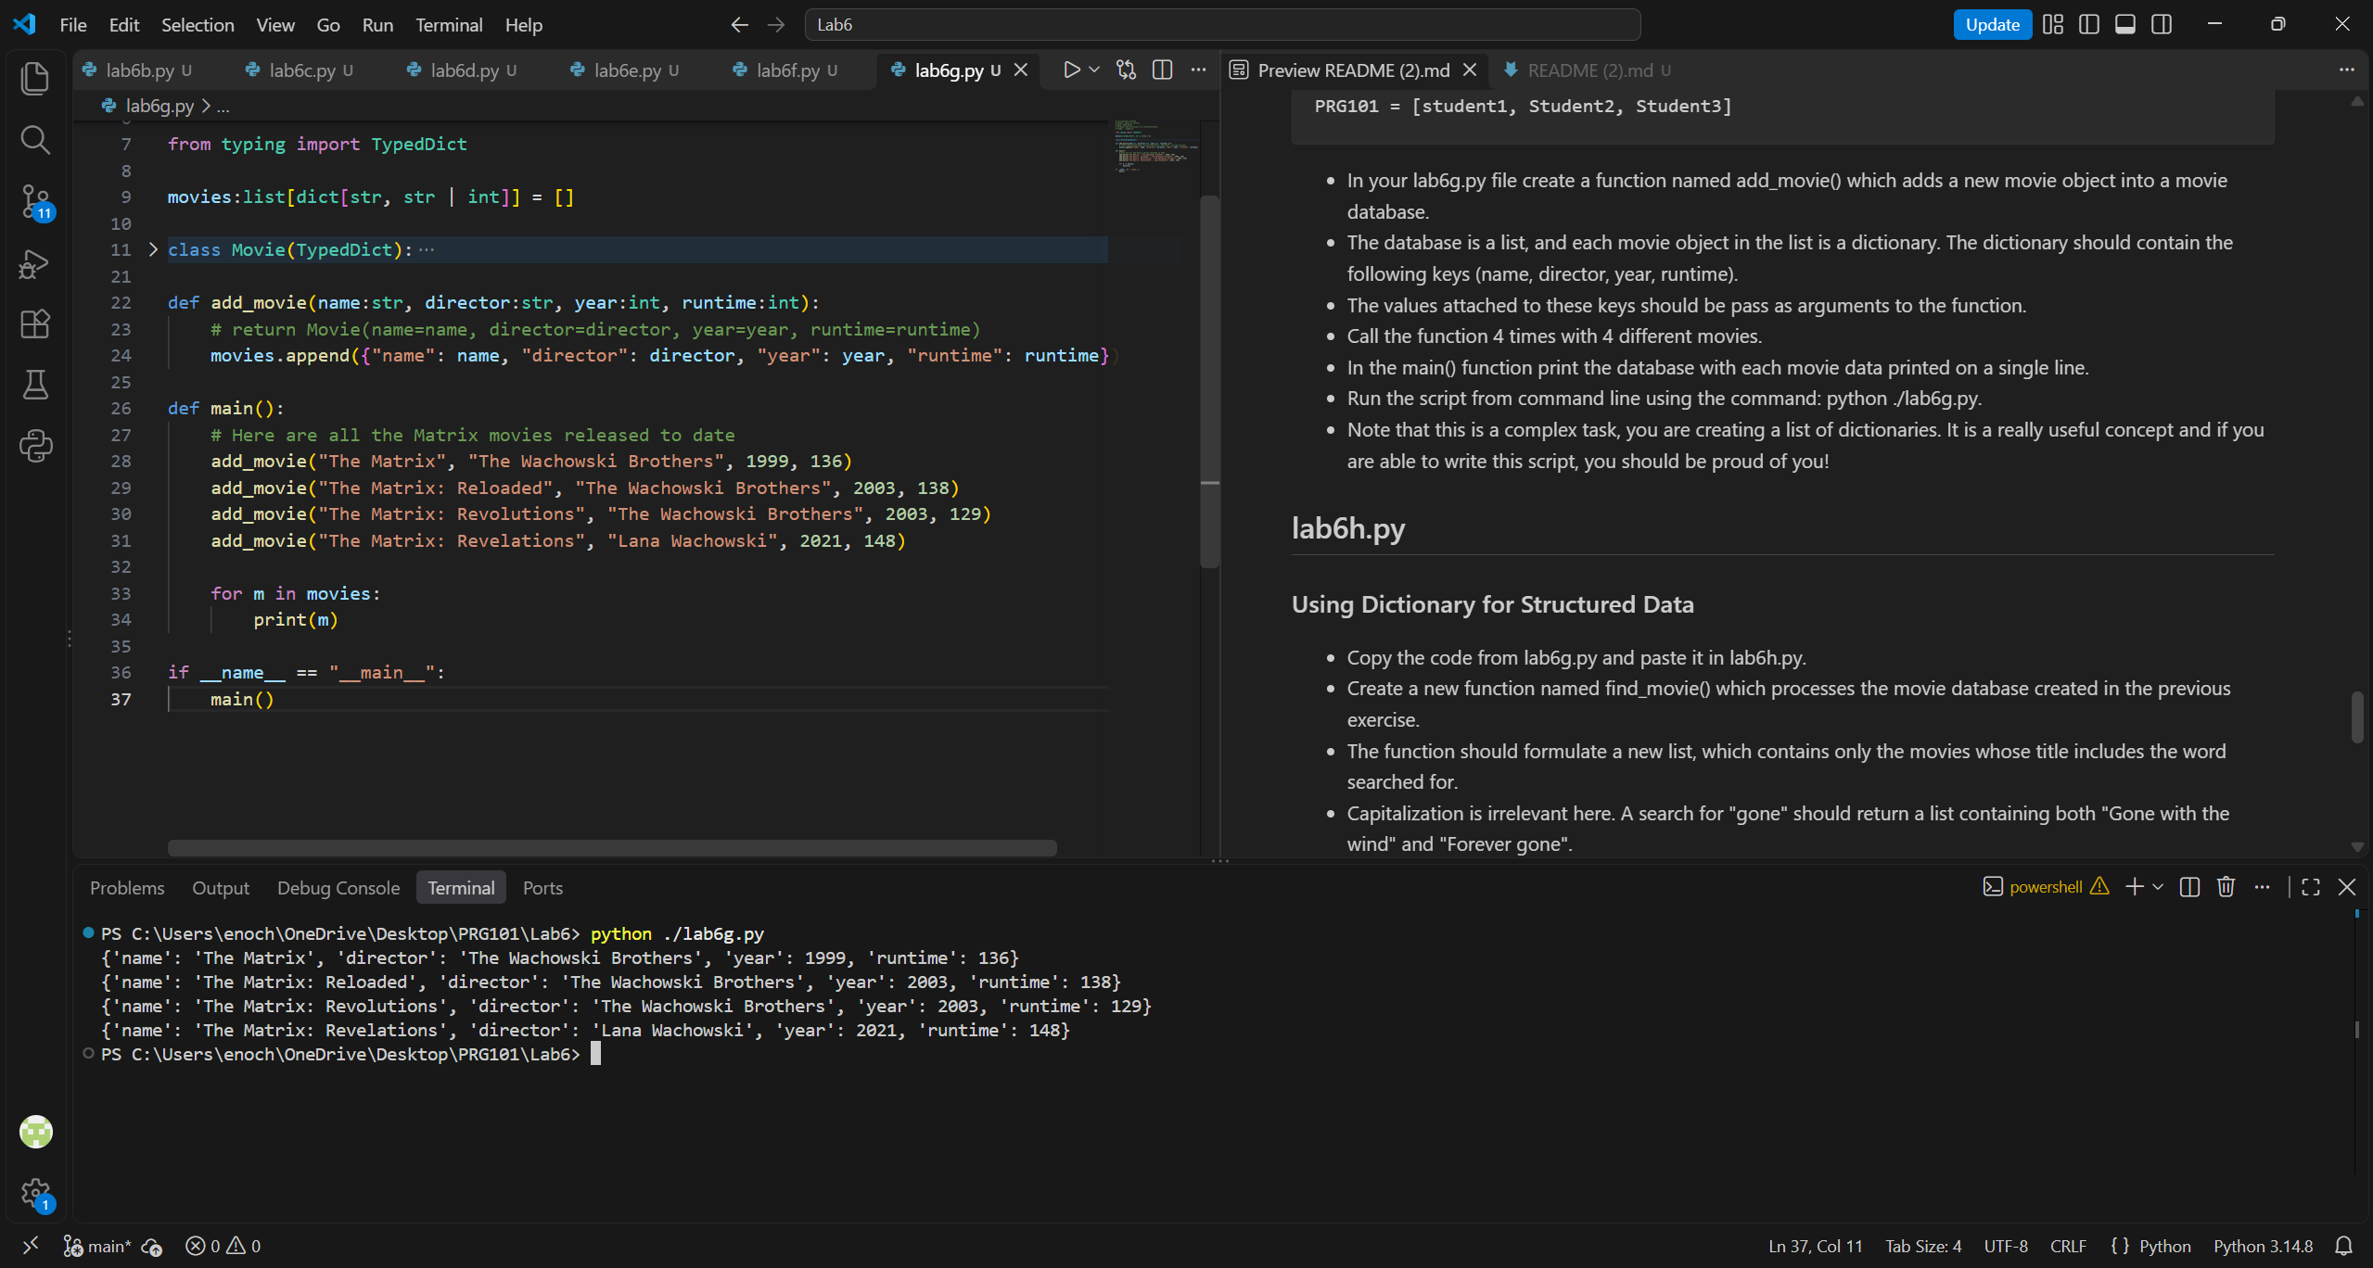
I’m not really proud of myself for doing this basic thing, and I can’t be bothered to pretty-print it.

Lab6h.py
Note: I decided to use my unused TypedDict class from the previous part solely because it makes me and my type checker happier.

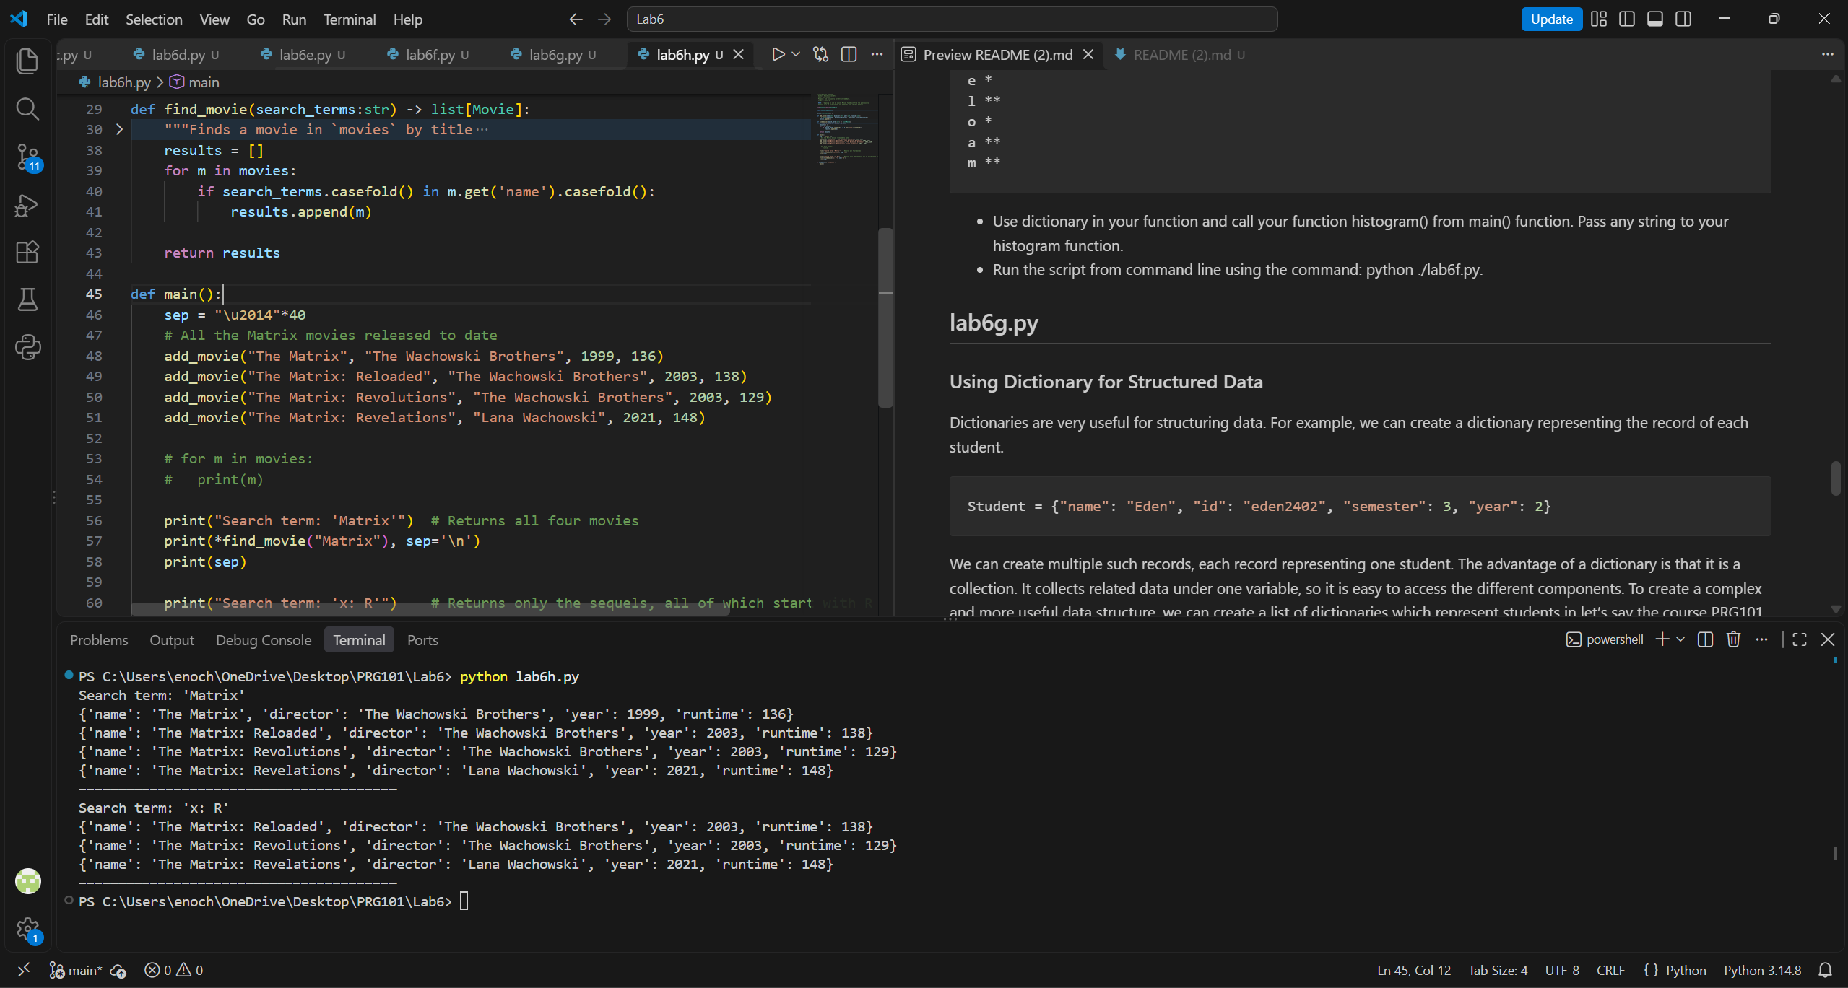
In the future, you might expect some variables to be enclosed in isinstance functions solely to satisfy my type checker.

